

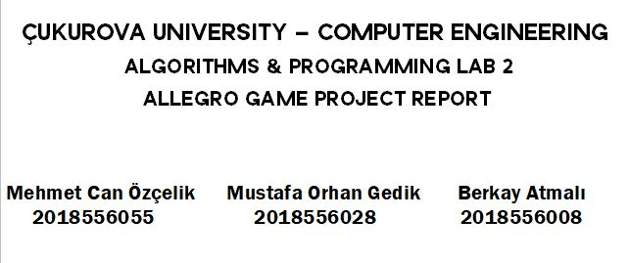

Our Project based on “Fit in the Hole ” Game.

1-) Principle of the Game:

-Program starts with 800x800 pixel screen on Windows Console Processor. In the levels, there is a main filled shape without one piece of square , an empty target shape and a 40x40 pixel square to move and find the correct shape.

-When the game starts, user needs to find correct position of moving square before the main shape reaches to target to pass the level.

-The little square and the main shape is moving by time. User can move little square but the main shape is always moves upwards.

-There is only one correct position of the moving square. If the user can not move the square to the right position before the main shape reaches target , game is over.

-If the user can move the square to the correct position, the other level starts with another shape. The principle of the game is always same in levels.

-There is no rank of difficulty between levels. The shapes are sent to the screen randomly.

2-) Main Algorithm:

-When the program starts, a number is produced by time-random function. With respect to this number, a level starts. We made 21 levels with 21 different shapes. Each level has its own number.

-When the level starts, the main shape with a unique color comes from the bottom of the screen. This shape moves automatically with ALLEGRO_TIMER function.

-The user moves the small square -which is also moves automatically with ALLEGRO_TIMER function- and tries to find the correct position. All moving operations is calculated with respect to x and y-axis. Also moving of the shapes means a moving illusion by deleting previous location of the shape and writing a new location of the shape in an array.

-There is a [50][2] array to move the little square with moving illusion and a variable which is independent and can increase or decrease with respect to process to move main shape upwards.

-Each level has its own IF-CONDITION which includes the locations of main and target shapes, the codes to understand whether user pass or fail the level and messages to the user.

-The movement process is controlled by keyboard. This process is added to the program thanks to ALLEGRO KEYBOARD functions.

3-)Features of the Program :

-In the 800x800 pixel screen , We made a white border and four little colored dots, to make the screen look more beautiful. Also all shapes are colored in the black screen. That was everything we could do to make the black screen look nice.

-The original “Fit in the Hole” game is very difficult. We made our game easier than it. In the original game, user must move the square to the correct position right on time. However in our game, user can move the square faster and try to find the correct position and pass the level before the main shape reaches to the target.

4-) Difficulties and Our Solutions :

-In the first day, we have no idea about making a game in C Programming Language with Allegro Library. We made a research to find some documents and watched videos about Allegro library which is produced by our instructors.

-We needed a moving algorithm like a snake game and we took help from this snake game code to moved little square.

-Moving of the main shape was a little bit stronger. We made a target shape and a same main shape without one little square. This main shape's y-axis coordinate was dependent on default location. We assigned it an independent variable and changed it with respect to keyboard moves.

-It was also difficult to understand whether the user passed or failed the level so we made sure that the program checks that the shapes are in the correct coordinate in x and y-axis.

-Moreover, when the user passed the level, the next level was not start from the bottom of the screen. We needed a solution for this and we decided to reassigned coordinates when the user pass level in If Condition.

-Besides, writing of 21 levels with 21 unique shapes was difficult as well. But we divided the shapes in pieces and made them more simple. We copied codes from our main prototype and just changed some coordinates.

-In the end of the project, we are happy to achieve something. We made a game even though it is not perfect with C-Programming Language.

